#include<iostream>

using namespace std;

int store(int arr[])

{

int min;

min=arr[0];

for(int j=0;j<=9;j++)

if(arr[j]<min){

min=arr[j];

}

cout<<"minimum: "<<min;

}

main(){

int a[10];

cout<<"enter 10 values in array: ";

for(int i=0;i<=9;i++)

cin>>a[i];

store(a);

}

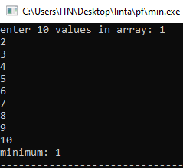

#include<iostream>

using namespace std;

int store(int arr[])

{

int max;

max=arr[0];

for(int j=0;j<=9;j++)

if(arr[j]>max){

max=arr[j];

}

cout<<"maximum: "<<max;

}

main(){

int a[10];

cout<<"enter 10 values in array: ";

for(int i=0;i<=9;i++)

cin>>a[i];

store(a);

}

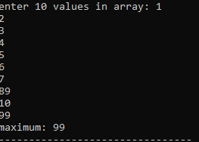

#include<iostream>

using namespace std;

int store(int arr[],int n)

{

int temp;

for(int j=0;j<=9;j++) {

if(n==arr[j])

temp++;

}

if(temp!=0)

cout<<"number is available.";

else

cout<<"number is not available.";

}

main()

{

int m;

int a[10];

cout<<"enter 10 values in array: ";

for(int i=0;i<=9;i++)

cin>>a[i];

cout<<"enter value: ";

cin>>m;

store(a,m);

}

